Please check the examination details below before entering your candidate information
Candidate surname | Other names
PECK | CAMERON JOHN
Centre Number | Candidate Number
52137 | 7111
Pearson Edexcel Level 3 GCE
Release date: Monday 1 September 2025
Submission date: Friday 15 May 2026
 |  | Paper Reference | 9MT0/02
Music Technology
Advanced
COMPONENT 2: Technology-based composition
Logbook and authentication form
You must have:
The brief and video provided on the Pearson website.

Instructions for Teachers
- The logbook and authentication form must be completed and presented for
assessment along with the technology-based composition.
- The logbook and authentication form must be uploaded in the format
detailed in the Administrative Support Guide found on the Pearson website.
- Centres must retain backup copies of all logbooks.
- All assessment materials must be uploaded by 15 May 2026.
Information for Candidates
- The total mark for this component is 60.
- Do not attach additional material.
- The sections in this booklet ask you for information which is essential for the
examiner who assesses your work.
- If you do not complete the logbook and authentication form, your work may not
be fully credited.
- Export your logbook as a .pdf file named ‘9MT002_centre number_candidate
number_name’ (e.g. 9MT002_12345_6789_BloggsJ).

Brief chosen | Brief 3- SMASH!
Title of your composition
2000: An bass (like the fish) odssey
Use the following tables to detail how you have created sounds for your technology-based composition.
Synthesis
K2 – 0:00 – 0:39 – 0:40 – 0:44 – 1:24 – 1:36 – 2:25 – 2:42 – 2:46 – end  Backing synth | 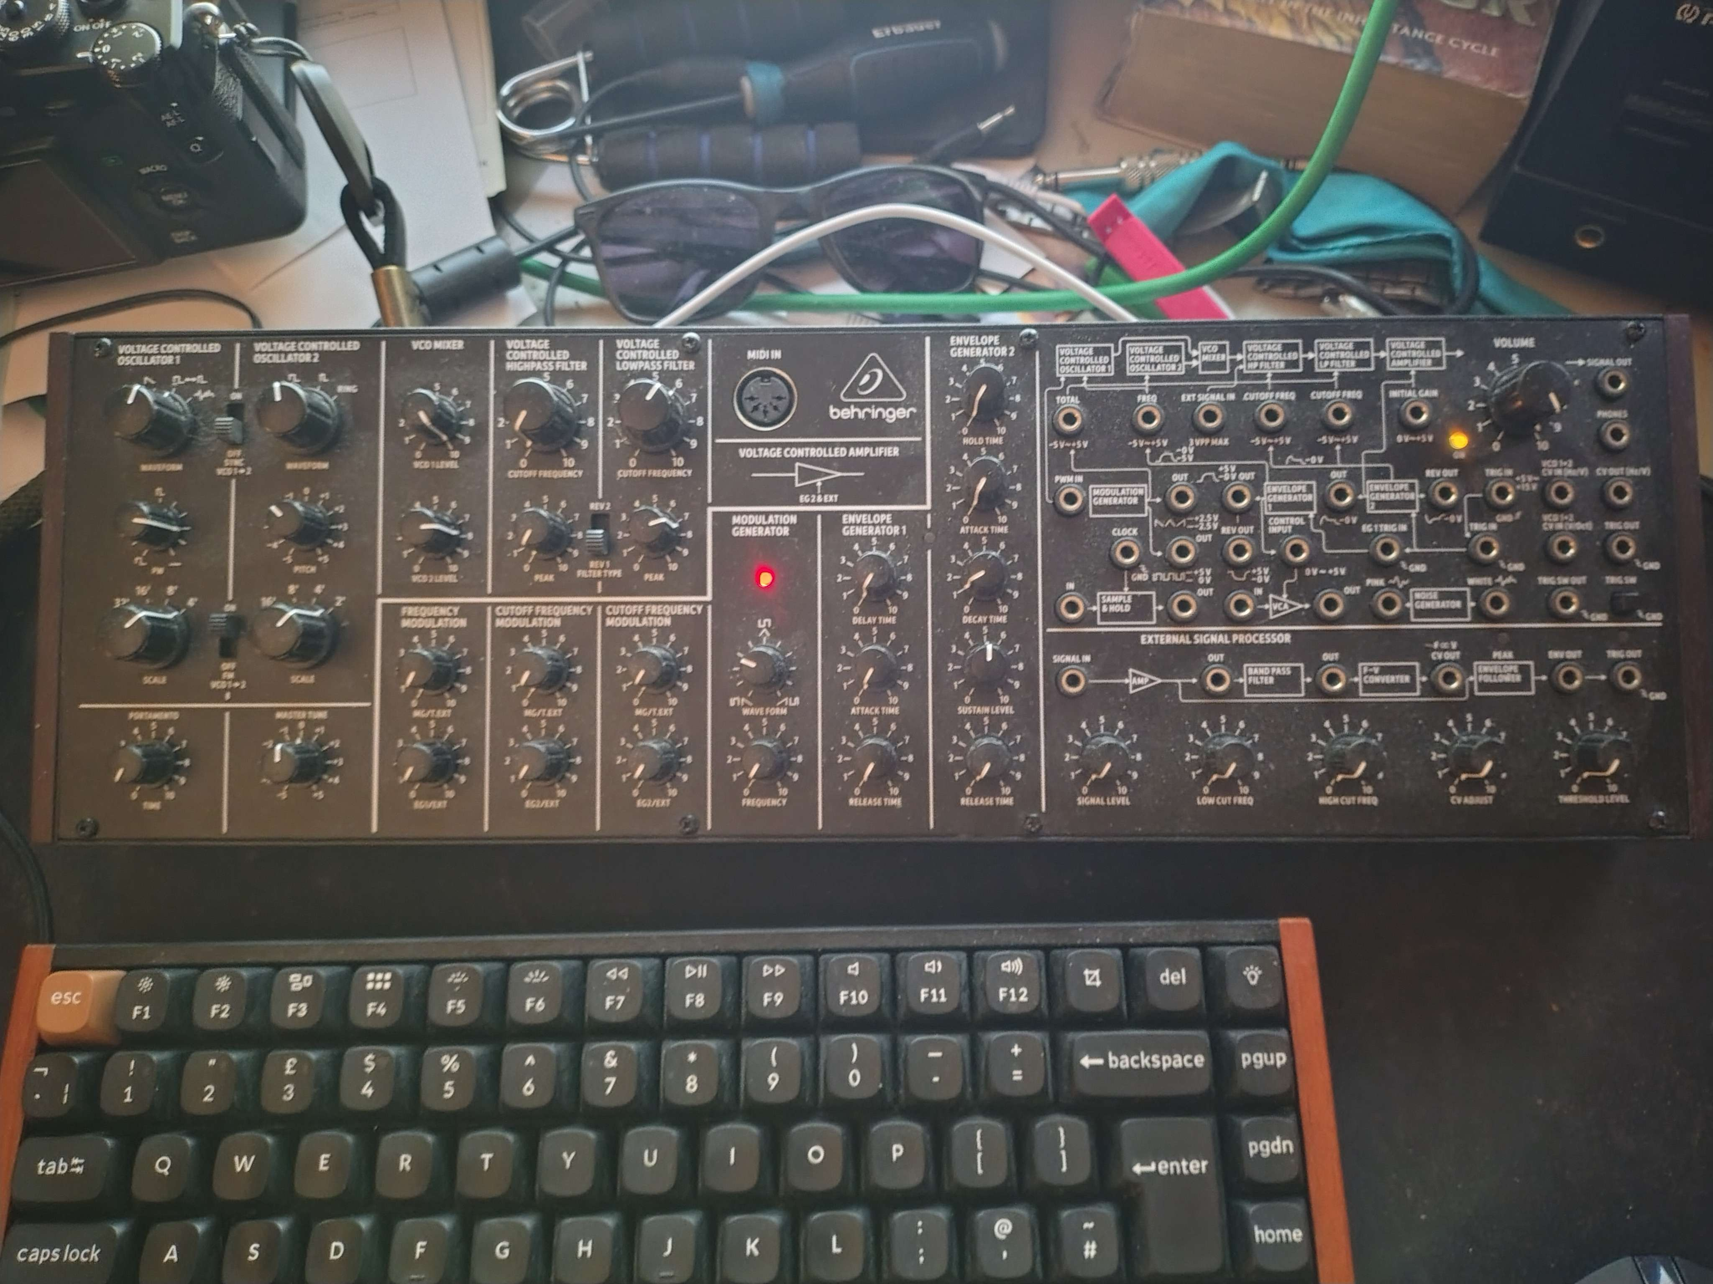  - Sound made using two oscillators, a fourth apart.  - Pulse wave and square wave  - Liberal filter automation  - A strong delay has been applied to the synthesizer  It acts to fill out the sound somewhat

Sampling
Timbre/instrument name | Using short audio files to develop new sonic elements; pitch-mapping, cutting/trimming, looping. Include any use of  AI-generated audio
Bin lid dropped on floor | 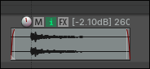  Unedited  Present at 0:20
Keys dropped on table | 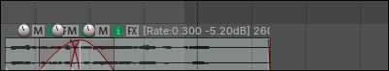  Present at 0:23  Extreme chaotic delay used
Pan interior hit | 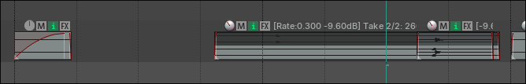  Presnet at 0:46  Same chaotic delay as keys
Paperclips dropped on table | 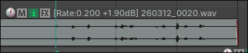  Present at 0:47  Chaotic Delay
Reversed metal impact | 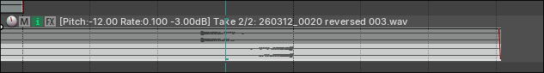  Present at 0:50  Reversed chaos delay with quick time, creating a drawn out tail
Bin lid hit with drum stick | 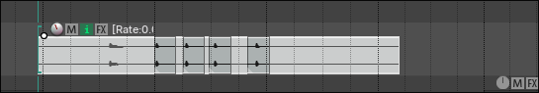  Reversed chaos delay, repeating creating an interesting texture  Present at 1:54
Small pot smashing sound | 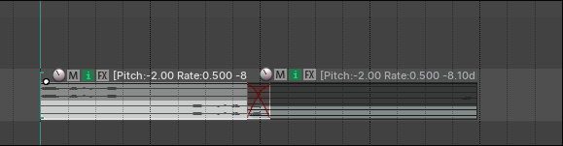  Reversed and stacked with its forward version  Reversed delay  Present at 2:46
Bass Guitar | 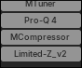  - Compressed and limited to try and make it more dynamically consistent

Creative effects
Timbre/instrument name | Adding effects or processors to modify existing sounds; control of parameters and use of AI-generated effects
Double tracked octave shifted guitar | Pitch shifted an octave up with a stacked fifth.  Distorted  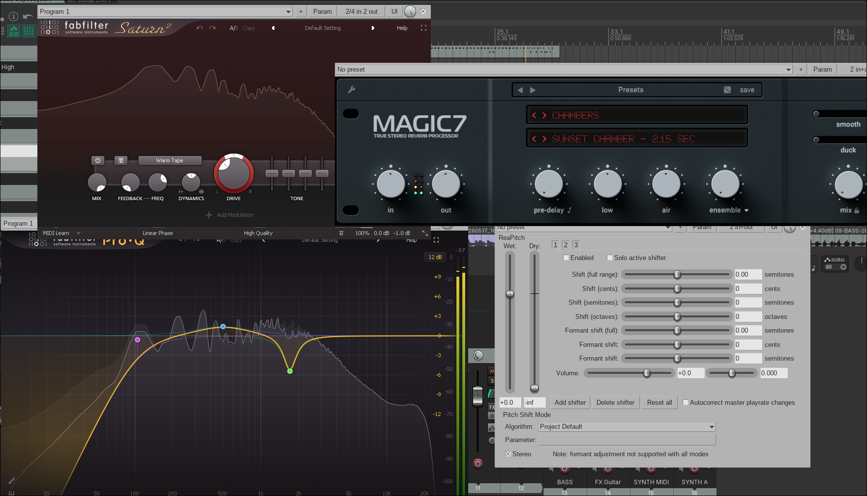  Eqed to sit in the mix, with some light reverb
Double tracked, fifths guitar | Similar to first guitar, except without the verb or octave increase
FX Guitar | 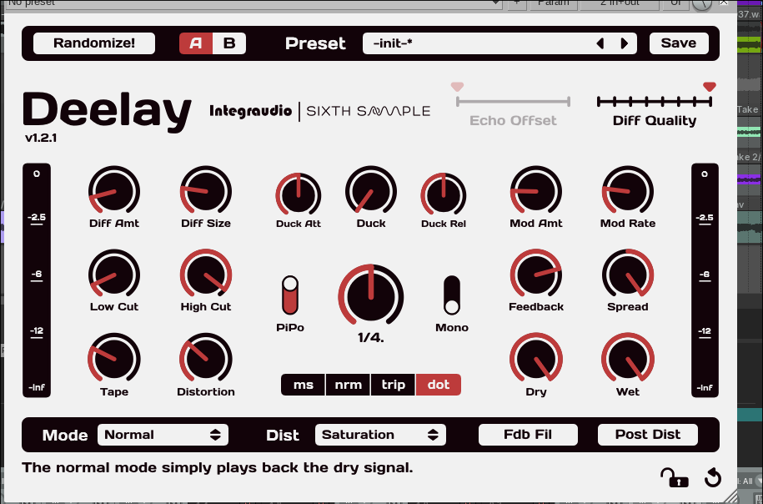  Guitar with a dotted reverb applied, creates an interesting effect where the transient hits several times. I also used a volume pedal to record swells, removing the transients entirely. This setup is similar to the frippatronics setup used by Fripp and Eno for the album “No pussyfooting” as well as some tracks on “Another Green World”.
Airy synth | 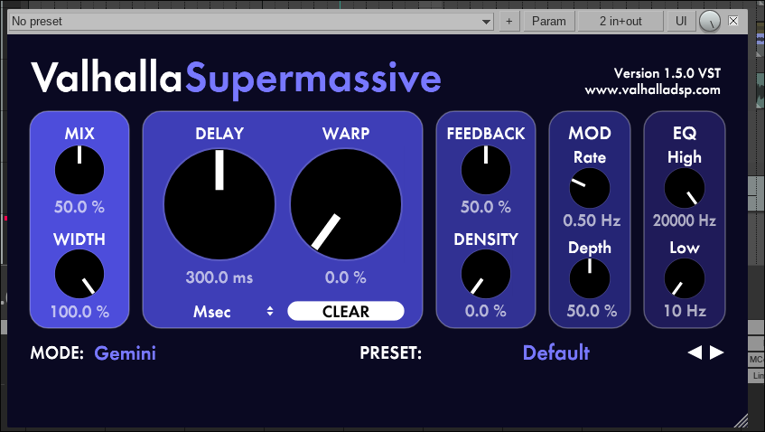  Combined reverb/delay unit has been used to draw out the envelope of the synth, since it is only monophonic.
ALL OTHER CREATIVE FX MENTIONED UNDER SAMPLES

State any parts played by other performers, including AI, and details of how you directed and manipulated the performance
Instrument/part | Name of performer | How you directed the performance | Editing and manipulation of recorded audio/MIDI
Impact Samples | Mr. Diamond | We suggested things to record | I recorded this on my portable tascam recorder, with a doubled track brought 6DB down incase of clipping. This sound was manipulated to create the “SMASH!” sounds.

Teacher declaration
I declare that the work submitted for assessment has been carried out without assistance other than that which is acceptable according to the rules of the specification. I certify that, to the best of my knowledge, the evidence submitted for this assignment is the candidate’s own. The candidate has clearly referenced any sources and any AI tools used in the work. I understand that false declaration is a form of malpractice.
Teacher name:
Teacher signed: |  | Date:
Email address:
Candidate declaration
I certify that the work submitted for this assessment is my own. I have clearly referenced any sources and any AI tools used in the work. This work has not been submitted for assessment for any other qualification. I understand that false declaration is a form of malpractice.
Candidate signed: |  | Date:
Please present this completed form with the candidate’s submission.
By signing the above declaration, you agree to your work being used to support professional development, online support and training of both centre-assessors and Pearson examiners.
If you have any concerns, please email: teachingmusic@pearson.com

